

**AN AI-BASED APPLICANT TRACKING SYSTEM FOR HUMAN RESOURCE**

**BATCH 2021**





Student 1: - Vishaka Pahuja Roll# 023-21-0344

Student 2: - Mohammad Yaqoob Roll# 023-21-0335

Supervisor: Sir Rizwan Abro

TABLE OF CONTENTS

ABSTRACT 2

1.0 INTRODUCTION AND BACKGROUND 2

2.0 PROBLEM STATEMENT 2

3.0 LITERATURE REVIEW 3

4.0 OBJECTIVES 3

5.0 TARGETED USERS 4

6.0 METHODOLOGY 4

6.1 ARCHITECTURE DEVELOPMENT 4

6.2 WEBSITE DEVELOPMENT 5

7.0 TECHNOLOGIES 5

8.0 COSTING 6

9.0 Project Milestones and Deliverables 6

10.0 Work Division 7

11.0 CONCLUSION 8

12.0 REFERENCES 8

# ABSTRACT

Hiring new employees can be slow, inconsistent, and resource intensive. Recruiters often struggle with sorting through large numbers of resumes, managing time effectively, and keeping track of applicants. This can lead to delays, missed opportunities, and difficulties in the selection process. To address these challenges, this project involves creating a comprehensive website that leverages advanced AI technologies to streamline the hiring process. The website will automatically process and analyze resumes using Natural Language Processing (NLP) and machine learning algorithms. Candidates will be scored based on their qualifications, and AI-generated job-specific assessments will further evaluate their suitability for the role. After evaluating candidates, the system ranks them, provides instant feedback, and selects the top performers for interviews. By automating these tasks, the system helps recruiters manage time better and reduces resource usage. It also improves applicant tracking by keeping all candidate information organized and accessible. This AI-based ATS aims to eliminate human biases, reduce delays, and improve the credibility and accountability of the HR department. This project not only addresses the common challenges faced in recruitment but also aligns with the growing trend towards automation and AI in business processes.

# INTRODUCTION AND BACKGROUND

As technology advances, the departments of human resource in industries feel pressure to increase their performance when it comes to the hiring of employees. In the past, hiring activities have been done through resume review, subjective selection, and multiple administrative tasks that lead to long periods of recruitment, increased possibilities of bias, and inconsistency in the selection process. These difficulties are compounded by the volume of application when the organizations grow and receive many applications that it is hard for them to recruit fairly and efficiently. The ability to screen and evaluate applicants through an AI-Based Applicant Tracking System(ATS) come with a solution to these problems. An AI-Based ATS can assess candidates by analyzing their resumes, conducting online aptitude tests, and ranking applicants based on pre-defined criteria. By integrating machine learning(ML) models and natural language processing(NLP), this system is capable of assessing candidates’ skills and experience and decide whether or not they should be invited for the interview and without involving a recruiter at all, thus reducing bias and saving considerable amounts of time for screening. The suggested project aims at the increasing demand for the automatic solutions in the companies’ HR departments, that causes high recruitment volumes, both for the large companies that need to solve a wide range of tasks in recruitment and for the companies that want to optimize their work in this sphere. With the help of this ATS solution, the HR teams will retain the highest levels of transparency and accountability and simultaneously disengage from spending time on routine tasks.

# 2.0 PROBLEM STATEMENT

Current traditional methods of candidate sourcing are disadvantageous in that they are time consuming, prone to bias and hence leads to operational costs, delays and low diversity. Manual resume screening, taking up to seven minutes per resume, hinders HR teams from processing large volumes of applications efficiently. An AI-Based Applicant Tracking System (ATS) eliminates these issues through automated processes involving applicant filtering, testing and ranking. This improves efficiency, reduces bias, and helps organizations optimize talent acquisition while focusing on strategic HR contributions.

# 3.0 LITERATURE REVIEW

The integration of Applicant Tracking Systems (ATS) and artificial intelligence (AI) in recruitment processes has significantly enhanced efficiency, transparency, and decision-making. Ogwueleka et al. [1] demonstrated how an ATS implemented for Nigeria’s Federal Road Safety Corps automated workflows such as shortlisting and scheduling, effectively reducing costs and operational risks. Similarly, Laumer et al. [2] highlighted that integrating ATS with Business Process Management (BPM) in Germany improved recruitment metrics such as time-to-hire and stakeholder satisfaction. Saad et al. [3] examined the challenges faced during e-recruitment adoption in Tanzania, identifying limited system integration and user resistance. The study emphasized the importance of regulatory frameworks and technical support for effective implementation. Meanwhile, Black et al. [4] discussed AI-driven ATS features like predictive analytics, which enhance decision-making but carry risks of algorithmic bias if not properly managed. Mishra et al. [5] validated that AI-powered ATS systems improve candidate experience and recruitment cycle times by integrating talent management tools. Recent advancements in ATS include leveraging Natural Language Processing (NLP) techniques for resume parsing and job matching. Kulkarni et al. [6] proposed using models like S-BERT and cosine similarity to improve the accuracy of resume screening, reducing biases and ensuring better candidate-job fit. These approaches help identify the most relevant candidates quickly, saving time and costs. Additionally, Guo et al. [7] introduced ResuMatcher, an AI-powered resume-job matching system that uses advanced algorithms to analyze candidate profiles. The system demonstrated improvements in identifying top candidates while maintaining fairness. Another study by MDPI [8] explored machine learning’s role in integrating ATS with eye-tracking data to assess recruiter decision-making, offering insights for optimizing AI-assisted hiring processes.

# 4.0 OBJECTIVES

* **Automate CV Analysis:** Employ the AI parsing methods to work through the data of CVs in the shortest possible time with a least human interference and achieve maximum accuracy.
* **Conduct Candidate Assessments:** Provide possibilities for online testing to evaluate such candidates with regard to the necessary skills and competencies through such tests.
* **Streamline the Recruiter and Candidate Experience:** Make better interaction designs that enables easy tracking of applications and working on reviews that will enhance the employers’ hiring system.

# 5.0 TARGETED USERS

* **HR Professionals**: Recruiters and hiring managers streamline tasks like resume screening, candidate assessments, and decision-making.
* **Job Applicants**: Access a transparent hiring process, track applications, and complete assessments efficiently.
* **Organizational Management**: HR directors and business owners benefit from improved hiring metrics and reduced bias.
* **IT Teams**: Ensure smooth system integration and data security.
* **Industries**: Medium to large enterprises, startups, and educational institutions seeking efficient recruitment solutions.

# 6.0 METHODOLOGY

The approach used to design and implement the AI-Based Applicant Tracking System (ATS) involves the architectural approach, implementation approach and web application approach. This methodology focuses on the development of a strong architecture or framework that enhances the flow of data and communication between the components with incentive towards the accommodation of future modifications. The implementation phase focuses on developing AI models for CV scanning, predictive analytics, and integration with existing HR systems, followed by testing and fine-tuning. The web application development process involves defining specific features and designing an intuitive user interface for real-time monitoring of applicant data, predictive insights, and management of the hiring process. In summary, the methodology is intended to present the straightforward approach for hiring away special talent, minimize bias during talent selection, and provide the datasets useful for the HR departments to make informative decisions.

.

## 6.1 ARCHITECTURE DEVELOPMENT

## 6.2 WEBSITE DEVELOPMENT

* + - * 1. Feature Specification: Define the specific functionalities that the website will offer, such as real-time monitoring of applicant status, notifications for new applications, analytics dashboards for HR metrics, and user management features for HR personnel.
        2. User Interface Design: Create an intuitive and visually appealing interface for the website that allows users to navigate easily.
        3. Frontend and Backend Integration: Ensure seamless integration between the frontend and backend systems to facilitate smooth data flow and user interactions.

7.0 TECHNOLOGIES

**Programming Languages:**

* Python: For backend development, machine learning, and NLP.
* JavaScript: For creating a dynamic and interactive front-end.

**Frameworks:**

* Django: Backend framework for routing, APIs, and server-side logic.
* React: Frontend library for building user interfaces.

**Machine Learning and NLP Tools:**

* spaCy: For natural language processing and resume parsing.
* TensorFlow/PyTorch: For training machine learning models.

**Database:**

* MongoDB: A NoSQL database for flexible, schema-less data storage, ideal for handling diverse and dynamic applicant data formats.

8.0 COSTING

|  |  |  |  |  |
| --- | --- | --- | --- | --- |
| | **Category** | **Cost**  **(USD)** | **Cost (PKR)** | **Details** | | --- | --- | --- | --- | |
| |  |  |  |  | | --- | --- | --- | --- | | **Total Budget** | **$714** | **200,000** | Focused on open-source tools and cost-effective services. | |
| |  |  |  |  | | --- | --- | --- | --- | | **Cloud Services** | $150 | 42,000 | Use free-tier services (AWS Free Tier or Google Cloud's free credits). | |
| |  |  |  |  | | --- | --- | --- | --- | | **NLP and Machine Learning** | $200 | 56,000 | Utilize open-source libraries like spaCy, TensorFlow, and PyTorch. | |
| |  |  |  |  |  | | --- | --- | --- | --- | --- | | **UI/UX Design Tools** | $250 | 70,000 |  | Leverage free Django and React tools with minimal paid plugins. | |
| |  |  |  |  | | --- | --- | --- | --- | | **Testing and Optimization** | $100 | 28,000 | Use open-source tools like Selenium, PyTest, and free versions of Postman. | |
| |  |  |  |  | | --- | --- | --- | --- | | **Miscellaneous Costs** | $14 | 4,000 | Minor expenses for hardware or unforeseen requirements. | |

# 9.0 Project Milestones and Deliverables

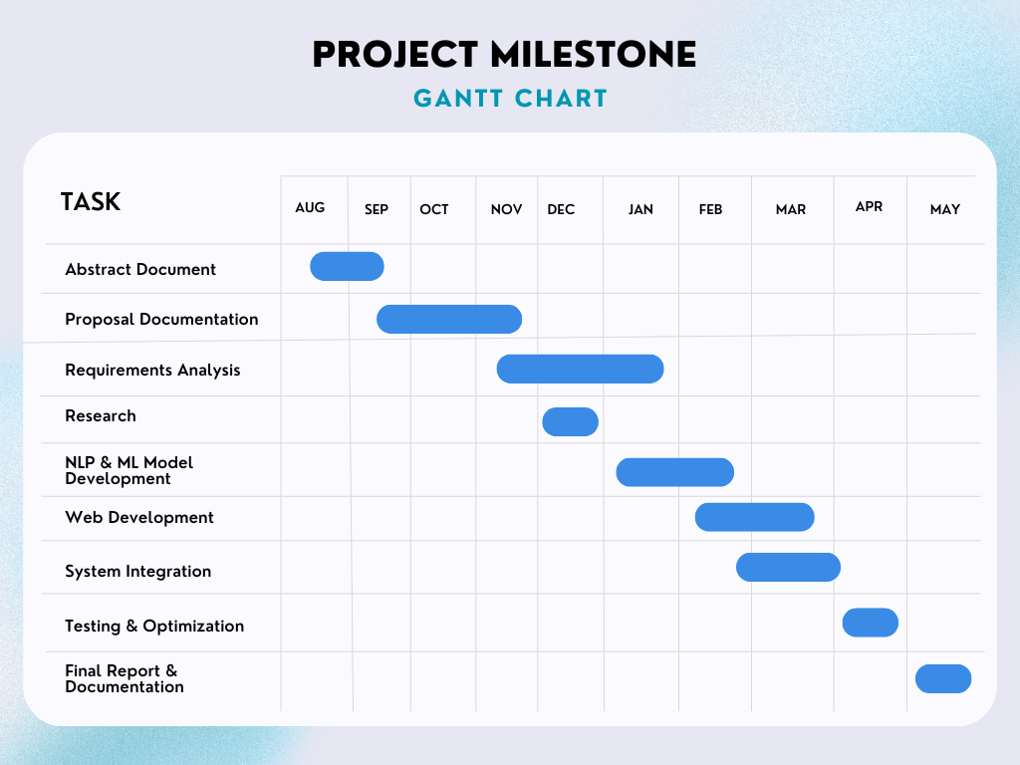

# 10.0 Work Division

|  |  |
| --- | --- |
| Team Member | Responsibilities |
| Vishaka Pahuja | Frontend Development (UI/UX design, integration with backend for seamless user experience, implementing applicant dashboard). |
| Mohammad Yaqoob | Backend Development (Database design and management, API development, integration of AI/ML modules). |
| Both | Documentation (Including project proposal, requirements specification, system design, implementation details, testing plans, user manuals, and project reports). |
| Both | Resume Processing System (Testing and integration of NLP-based resume analysis features). |
| Both | Candidate Assessment System (Development and testing of AI-generated job-specific assessments and scoring). |
| Both | Applicant Tracking System (Ensuring proper organization and accessibility of candidate information, testing, and improvements). |
| Both | Quality Assurance (Testing the entire system for bugs, fixing issues, and gathering user feedback for improvements). |

11.0 CONCLUSION

The **AI-Based Applicant Tracking System (ATS)** provides the highest level of selection, openness, and equity with the help of CV parsing, analyzing and using data for predictions. In-line with system architecture, AI model formulation and web deployment, ATS enables the HR teams to monitor and evaluate applicants in real-time on an easily navigated platform. This approach not only fast forwards candidate identification and minimizes bias but also optimize overall candidate acquisition results, setting up for further enhancements in the future. The ATS could thus be viewed as useful asset to HR departments as it enhances the role of AI in the hiring process, while also providing the means to ensure greater levels of responsibility for the head of HR departments.

# 12.0 REFERENCES

* F. Ogwueleka and A. Ismaila, “Applicant Tracking System for Nigeria Federal Road Safety Corps,” *British Journal of Applied Science & Technology,* vol. 6, no. 3, pp. 202–215, 2015. DOI: 10.9734/BJAST/2015/12910.
* S. Laumer, C. Maier, and A. Eckhardt, “The impact of business process management and applicant tracking systems on recruiting process performance,” *Journal of Business Economics,* vol. 84, no. 4, pp. 441–470, 2014. DOI: 10.1007/s11573-014-0758-9.
* A. Y. Saad and J. Itika, “An Investigation of the Transformation Process from Manual to E-Recruitment in Tanzania Public Service,” *Journal of Public Policy and Administration,* vol. 9, no. 1, pp. 1–19, 2024.
* K. Black and P. van Esch, “Pitfalls and Tensions in Digitalizing Talent Acquisition Using ATS,” *Interacting with Computers,* vol. 35, no. 3, pp. 435–448, 2021. DOI: 10.1093/iwc/iwab013.
* A. Mishra, R. Patel, and S. Verma, “Leading Talent Management: Empirical Investigation on ATS and E-Recruitment Performance,” *IEEE Xplore Conference Proceedings,* 2024. DOI: 10.1109/ICHR.2024.10111172.
* S. B. Kulkarni and X. Che, “Using Machine Learning with Eye-Tracking Data to Predict if a Recruiter Will Approve a Resume,” MDPI Journal of Intelligent Systems, vol. 28, no. 2, pp. 2–16, 2023.
* S. Guo and T. Hammond, “ResuMatcher: A Personalized Resume-Job Matching System,” Texas A&M University Research Publications, 2015.
* “Automated Resume Screening Using Natural Language Processing,” Journal of Emerging Technologies and Innovative Research, vol. 10, no. 3, pp. 510–525, 2023.